Below is a clear, in-depth, professional DAY 5 document on Test Planning & Traceability in Xray, written in simple language, aligned with Agile + real enterprise practices, and including step-by-step hands-on for every topic.
You can directly submit this for lab records, training reports, or internal assessment.

DAY 5 – TEST PLANNING & TRACEABILITY (XRAY)
1. Test Planning
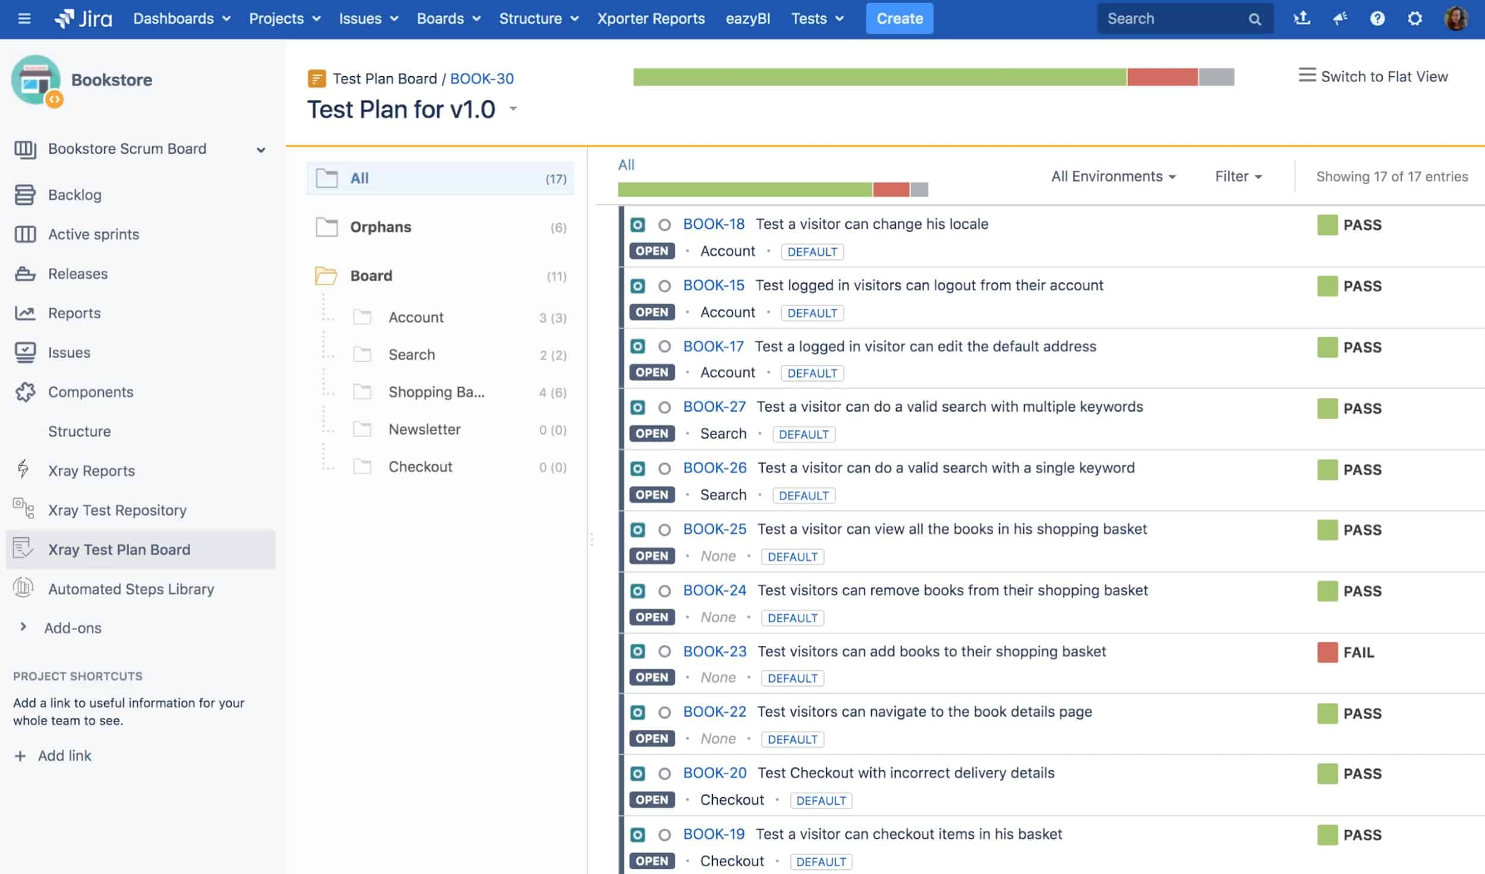
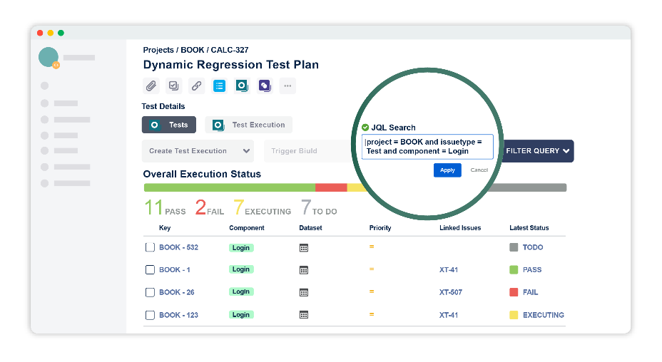

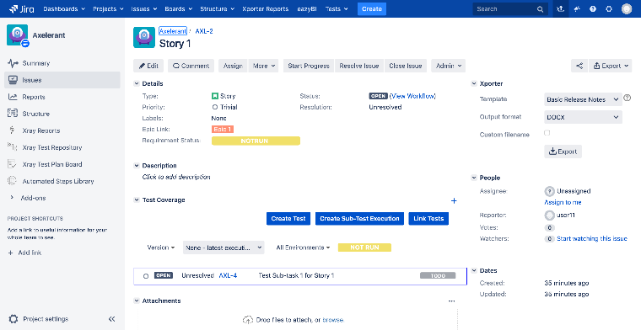
In Xray Test Management, Test Planning ensures that the right tests are executed at the right time for a sprint or release.

1.1 Test Plan – Concept
A Test Plan is a high-level container that defines:
- What to test
- When to test
- For which sprint or release
- Overall testing scope
📌 Think of Test Plan as:
“The testing roadmap for a sprint or release.”

1.2 Test Plan vs Test Execution
Aspect | Test Plan | Test Execution
Purpose | Planning & tracking | Actual execution
Timeframe | Sprint / Release | Single run
Contains | Tests & Executions | Test results
Question Answered | What should be tested? | What was tested?
👉 Relation:
One Test Plan can contain multiple Test Executions.

1.3 Sprint Planning with Test Plan
In Agile:
- Each sprint has defined stories
- Tests are planned before execution
Workflow:
Sprint → Stories → Tests → Test Plan → Test Execution
📌 Benefit:
Early visibility into test scope and readiness.

1.4 Release Planning
For major releases:
- Combine multiple sprint tests
- Track cumulative quality
- Monitor overall readiness
📌 Example:
Release 2.0 – Core Features Validation

2. Regression Strategy
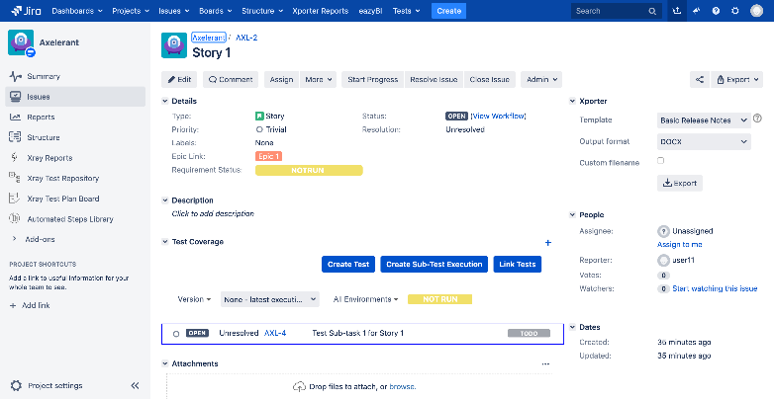

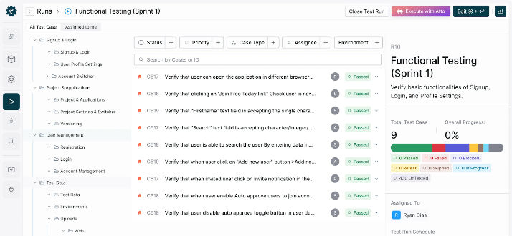

2.1 Regression Suites
Regression testing ensures existing functionality still works after changes.
📌 Regression Suite Includes:
- Core features
- High-risk areas
- Previously failed tests
In Xray, regression suites are maintained using Test Sets.

2.2 Reusable Test Packs
Reusable test packs are:
- Stable
- Well-maintained
- Used across multiple sprints/releases
📌 Examples:
- Login regression pack
- Payment regression pack

2.3 Smart Test Selection
Instead of running all tests:
- Select tests based on changed features
- Prioritize high-impact areas
- Reduce execution time
📌 Best Practice:
Combine Smoke + Targeted Regression for faster feedback.

3. Traceability
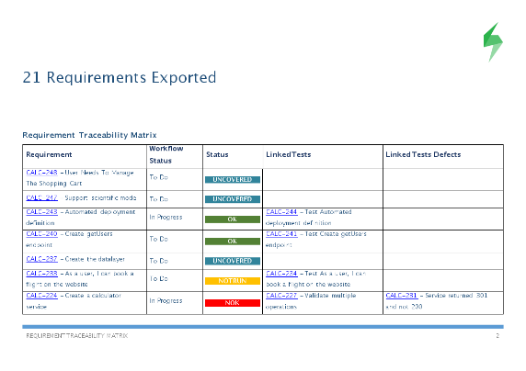
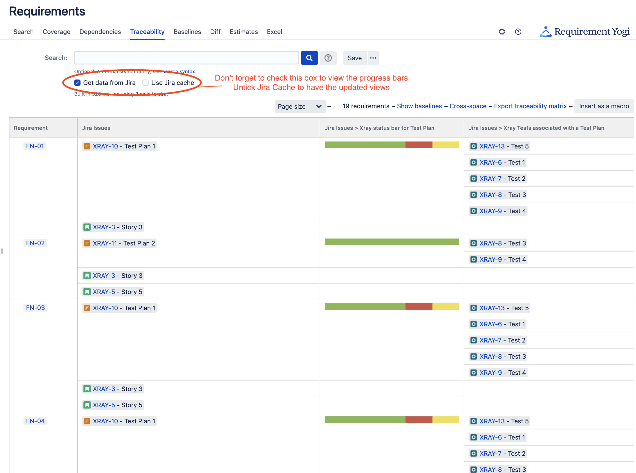
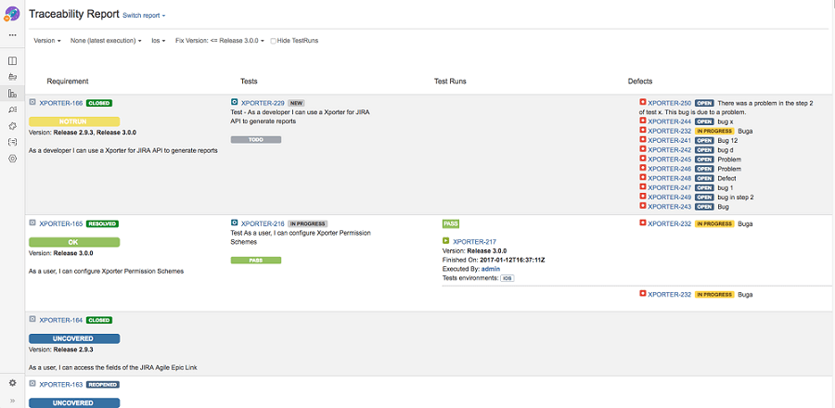

3.1 End-to-End Traceability Flow
Requirement → Test → Test Execution → Defect
This ensures:
- Every requirement is tested
- Every defect is traceable
- No functionality is missed

3.2 Coverage Matrix
The Coverage Matrix shows:
- Tested requirements
- Untested requirements
- Failed coverage areas
📌 How to View:
- Open Story
- Check Xray Coverage Panel
- Review linked Tests & results

3.3 Gap Identification
Gaps occur when:
- Stories have no linked Tests
- Tests exist but are not executed
- Failed tests have no defects
📌 Why Important:
Gaps indicate quality risks before release.

4. Compliance View
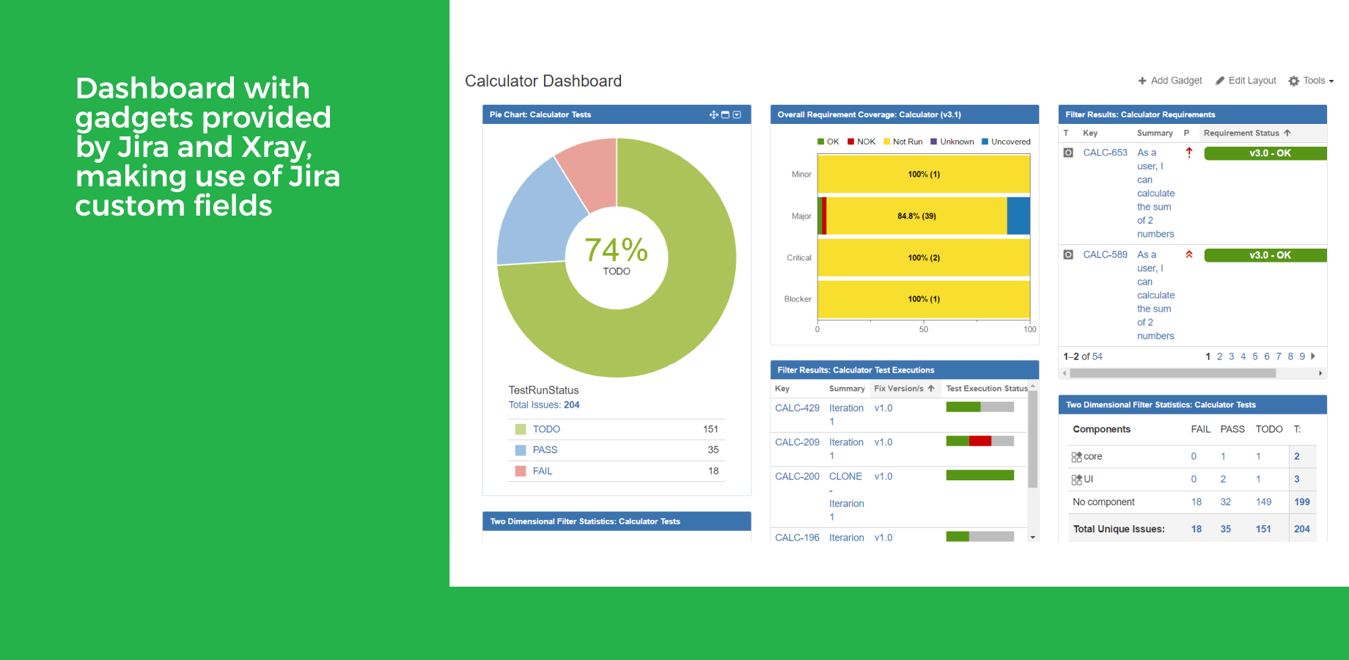

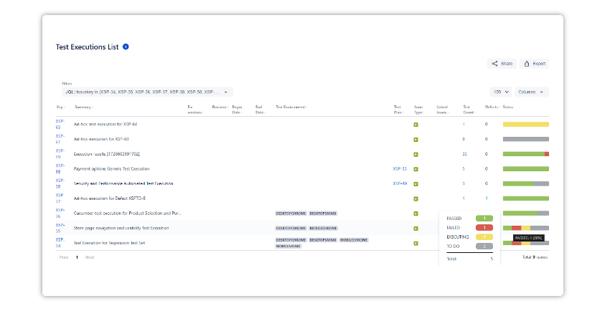

4.1 Audit Readiness
Xray provides audit-ready artifacts:
- Test cases
- Execution history
- Evidence
- Defect linkage
📌 Required in:
- Banking
- Healthcare
- Enterprise SaaS
- Government projects

4.2 Reporting Expectations
Stakeholders expect:
- Requirement coverage %
- Execution pass/fail trends
- Open defect count
- Release readiness status
Xray reports provide real-time visibility.

4.3 Stakeholder Visibility
Different stakeholders see different views:
- QA Lead: Coverage & execution
- Developer: Failed tests & defects
- Manager: Release quality dashboard
📌 Benefit:
One tool → multiple perspectives.

5. Hands-on Lab (Mandatory)
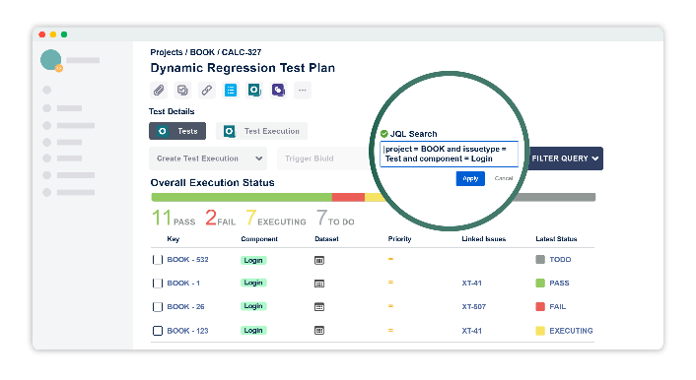
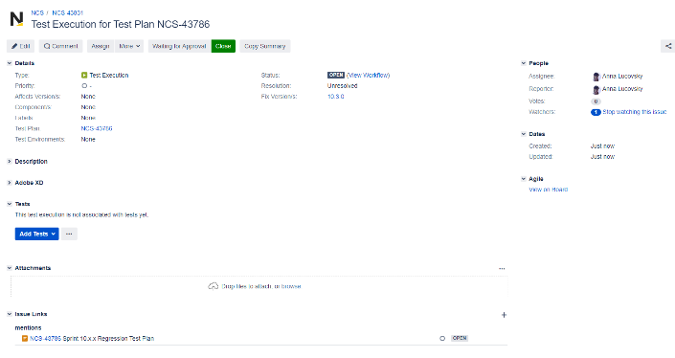

🔹 Task 1: Create a Test Plan
- Create Issue → Test Plan
- Name it: Sprint 4 – Test Plan
- Add relevant Tests

🔹 Task 2: Link Test Executions
- Open Test Plan
- Add existing Test Executions
- Verify execution progress

🔹 Task 3: Validate Requirement Coverage
- Open a User Story
- Check Coverage Panel
- Confirm:
  - Tests linked
  - Execution results visible

🔹 Task 4: Identify Gaps
- Find one Story without Tests
- Add missing Test
- Recheck coverage

6. Summary
Day 5 focused on test planning, regression strategy, traceability, and compliance readiness.
By mastering these concepts, students can:
- Plan testing efficiently for sprints and releases
- Maintain reusable regression assets
- Ensure end-to-end traceability
- Deliver audit-ready quality reports

